 | AIN SHAMS UNIVERSITY  Faculty of Engineering  Structural Engineering Department | 
16th International Conference on Structural and Geotechnical Engineering
Mega Projects: Bridges, Tunnels & Tall Buildings

1
2
TYPING INSTRUCTIONS FOR ICSGE-16 MANUSCRIPT
1
2
First and last name first author
Department of Civil Engineering, Any name University
Street, City name, Country name
E-mail: firstauthor@example.com
First and last name second author
Department of Civil Engineering, Any name University
Street, City name, Country name
E-mail: secondauthor@example.com
First and last name Third author
Department of Civil Engineering, Any name University
Street, City name, Country name
E-mail: thirdauthor@example.com
1
2

Abstract
This is where the abstract should be placed. It should consist of one paragraph giving a concise summary of the material in the article below. This template has been prepared in the format that should be used for the preparation of manuscripts. Replace the title, authors, and addresses with your own title, authors, and addresses. You may have as many authors and addresses as you like. Do not use footnotes in the text. The acknowledgments of funding bodies etc. are to be placed in a separate section at the end of the text. Please limit abstract to 200 words.

KEYWORDS
Please provide 5 to 10 specific keywords, e.g. composite floors, dynamic actions, shear connectors, steel sheeting, and acceptance criteria. Please avoid general phrases like “steel structures, innovative solution” etc.

1 Introduction
All authors are requested to provide their contribution in both word and pdf formats. The Proceedings for this conference will be printed using the submitted files. The manuscript file shall be prepared using Microsoft Word on international A4 size paper.
Please do not number your pages; the numbering will be done prior to printing the proceedings by the conference editorial committee. Each contribution is limited to 12 pages in total.

2 MAJOR HEADINGS
Major headings are typed in bold capitals; this is already pre-set in the format definition. They start at the left-hand margin on a separate line. The distances are pre-set in the format definition “headings major” to 12 pt before and 0 pt after the headings.

2.1 Secondary Headings
Secondary headings are typed in initial capitals, bold letters, and start at the left-hand margin and on a separate line. The distances are the same as for the major headings. Please limit the depth of headings to the proposed major and secondary headings.

2.2 Numbering of Headings
This template does not provide automatic numbering of headings, it is however recommended not to use automatic numbering, because the Word files will be used for printing and automatic numbering is sometimes misinterpreted depending on the computer or program settings. The format of the major and secondary headings is defined such, that after typing the number of the section a tab shall be used. The second line of long headings will be adjusted accordingly if no carriage return is used.

3 Page and paragraph format

3.1 Page size and margins
Please use the ISO A4 page format for preparing your manuscript. As the contributions will be delivered as electronic files it should be possible to save the document with the A4 page size. Table 1 gives the margins to be used in preparing the manuscript. With these margins the space available to the author is 15cm × 23.7cm (6.3″ × 9.72″).
Table 1: Paper size and margins
 | Paper size A4 (21 cm × 29.7 cm)
Margins | [cm] | [inch]
Top | 3.0 | 1.18
Bottom | 3.0 | 1.18
Left | 3.0 | 1.18
Right | 3.0 | 1.18
Use bold capitals for the manuscript title with 14 pt bold lettering. If you have a long title, please consider a Title, Subtitle format (as used in this template).
The full name(s), current employment, including mailing and e-mail addresses of the author(s) must be given below the title. An abstract of the manuscript and the beginning of the text should appear on the first page using 12 pt font sizes. Author(s) name(s) shall be typed in bold capitals, while affiliations shall be typed in initial capitals, Italic Letters.

3.2 Paragraph Template
All paragraphs shall be fully justified. No tab or indentation shall be used on the first line. Text shall be in 12 pt font size. The distances are pre-set in the format definition to 6 pt before and 0 pt after the paragraph.

3.3 Format Templates
This guideline contains format templates for most of usual types of text. In particular, the following format templates shall be used:
- format templates for headings
- format template “paragraph” for text
- format templates for description of Tables and Figures
- format template for formulas
- format template for lists
The above listed format templates are recommendations intended to simplify the preparation of the manuscript. This template shall also help to achieve a consistent appearance of all contributions.

4 Fonts to be used

4.1 Font Family
The font family to be used for the preparation of the manuscript shall be Times, and Times New Roman. Please do not switch typeface families within a document. For Greek letter like α or Λ use either the Symbol font or the extended Greek subset of the standard font.

4.2 Fonts in Figures and Equations
Please consider that, except in scanned images, the fonts used in figures, diagrams or equations shall be widely available. In addition to the Times-family, Arial and/or Helvetica fonts may be used in figures, as these fonts are usually available on any computer and printer. Other fonts should not be used.
For equations use the standard setting of the equation editor of Microsoft Word. An example of an equation is given below
$A=\frac{\sqrt{α^{2}}}{Ω}⋅e$ (1)
Where; A capital Latin letter
e small Latin letter
α small Greek letter
Ω capital Greek letter
The equation shall be centred with its caption right justified. The lines containing the list of variables are single spaced. Please use numbering of formulas when referring to them, e.g. see equation (1).

5 FIGURES AND TABLES

5.1 Figures
Clear illustrations enhance an article and often save words. It is imperative that all drawings and all lettering on illustrations be checked with great care before submission. Drawings shall be done on the computer or be made on white paper with black waterproof drawing ink and scanned as black and white bitmaps into the page where they are to appear in the text. Scanned diagrams shall have a resolution of 600 dpi (minimum 300 dpi) for figures scaled to 100%. Figures 1 and 2 illustrate the difference between high and poor quality of a scanned image. The preferable format for black and white images is tiff (compressed), JPEG is not recommended. Also, WMF or EPS figures may be included when observing the hints given in 4.2.
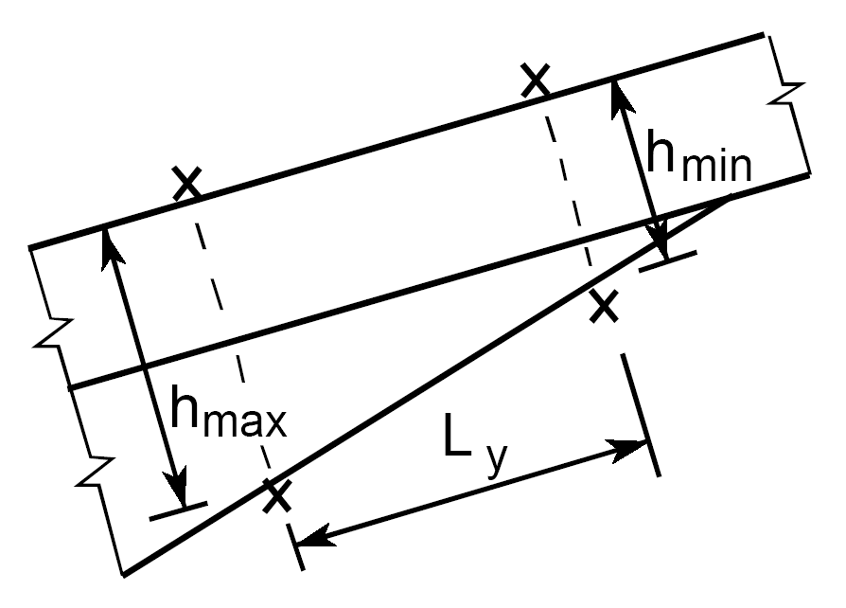  Fig. 1: Scanned image (high quality) | 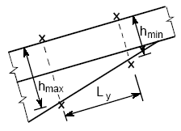  Fig. 2: Scanned image (poor quality)

5.2 Photographs
Photographs shall be embedded as grey-scale bitmaps; no colour photos should be used. Please include the graphics in the text file, do not include them as links to files or separate files. Only essential illustrative photographs shall be used because the reproduction quality of photographs often depends on the quality of the printing process and may lead to unsatisfactory results. The preferred format for photographs is tiff, the recommended resolution is 300 dpi, the minimum resolution is 150 dpi, the resolution applies to images scaled to 100%.
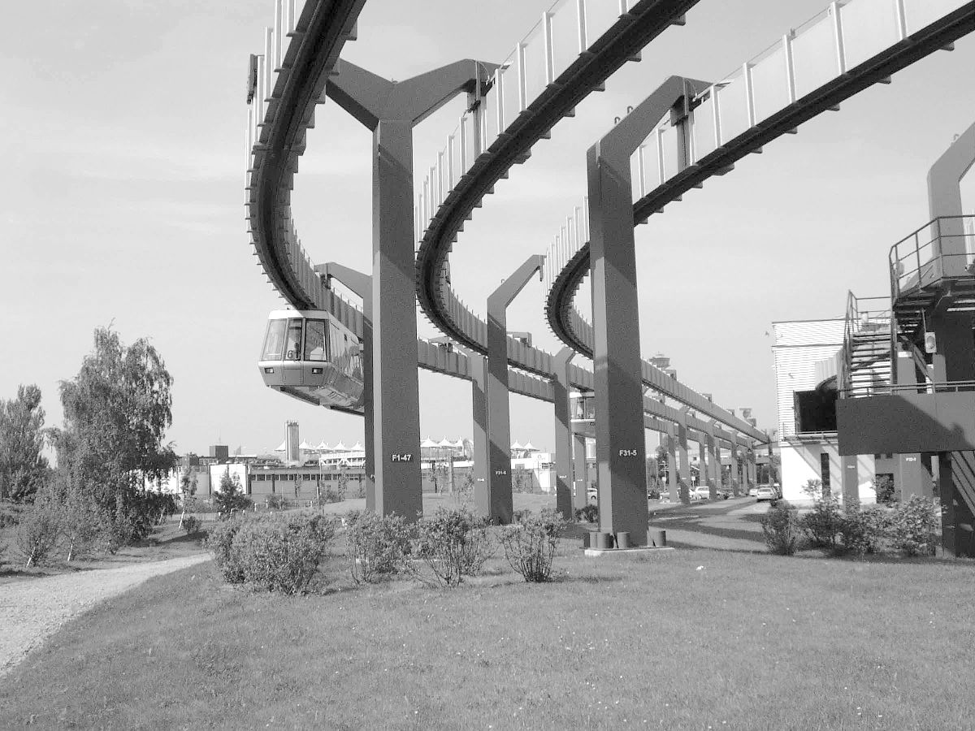
Fig. 3: Example of grey-scale photograph
The figures shall be centred (see Fig. 3) or arranged using tables (see Fig. 1 and Fig. 2). When using a table for the arrangement of figures, it shall also be justified horizontally to the centre of the page.
It is not recommended to use “positioning boxes” for the figures; it is more reliable to treat the figures as part of the text.

5.3 Tables
An example of a table is given above (see Table 1). Do not use vertical lines in the table. Place the tables centred; every table shall have a caption placed at the top, at least indicating the number of the table. Keep the tables simple, do not use background colours or shadings to emphasise single cells, use bold letters instead.

6 ACKNOWLEDGMENTS
Acknowledgments shall follow the text and before Notations or References.

7 Notations
It is recommended to explain used symbols and notations directly where they are used, see equation (1). In case the same symbols are used in different equations, a separate list of symbols may be provided in alphabetical order including units where applicable, see examples below:
Upper case Latin letters:
A area [m²]
E elasticity modulus [kN/cm²]
Lower case Latin letters
l length [m]
r radius [cm]
Upper case Greek letters:
Δ time period [sec]
Θ rotational moment of inertia
Lower case Greek letters:
ε strain
σ stress

8 references
Every author is responsible for respecting copyrights on figures, trademarks etc. included in the contribution. References shall be cited in the text in square brackets [1], and should follow the below format:
[1] Dhir, R.K., Hewlett, P.C., Lota, J.S. and Dyre, T.D. Materials and Structures 27 (1994) 606-615.
[2] Wang, J., Dhir R.K. and Levitt, M. Cement and Concrete Research 24 (8) (1994) 1463-1474.
[3] Mehta, P.K. Proceedings of the 2nd International Conference on Durability of Concrete, ACI SP-126, 1 (1991) 1-31.

